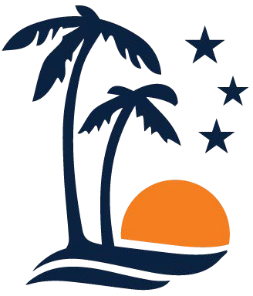
Leslie R. Swan VoteIndianRiver.gov
Indian River County Supervisor of Elections 4375 43rd Avenue
Vero Beach, FL 32967
772-226-4700
For Immediate Release
For Additional Information Contact:
Leslie Rossway Swan
772-226-4700
4375 43rd Avenue
Vero Beach, FL 32967
December 23, 2026

News Release

Florida Supervisor of Elections Association Offering
Scholarships to Florida College Students

Indian River County, FL - The Florida Supervisors of Elections Association is pleased to announce the availability of three scholarships, each valued at $1,200, to be awarded to deserving Florida College students in 2026.

These scholarships are designed to support students who demonstrate academic achievement, financial need, and a commitment to fields related to public service and civic engagement.

Interested students may obtain the scholarship application and review eligibility requirements online at VoteIndianRiver.gov or in person at the Indian River County Supervisor of Elections office, located at 4375 43rd Avenue, Vero Beach. The deadline to submit applications is March 6, 2026.

Eligibility Requirements
Applicants must meet all of the following criteria:
- Be a registered Florida voter
- Have lived in Florida for at least the two (2) years immediately preceding the application
- Be majoring in Political Science, Public Administration, Business Administration, or Journalism/Mass Communication
- Be enrolled or accepted as a junior or senior at an accredited Florida college or university
- Maintained a “C” grade point average or above for the previous academic year
- Demonstrate financial need

Selection Process
Applications must be submitted to the Supervisor of Elections Office in the county where the applicant is registered to vote. Each county will review submitted applications and select one finalist to forward to the Florida Supervisors of Elections Scholarship Committee for consideration.

“The Florida Supervisors of Elections Association is committed to promoting excellence in election administration and supporting civic education and engagement through the State of Florida. This scholarship program is a great opportunity to support students who are preparing for careers in public service, business, journalism, and leadership,” said Leslie Rossway Swan, Indian River County Supervisor of Elections. “All eligible students are encouraged to apply.”

For more information, students may visit VoteIndianRiver.gov or call 772-226-4705.

# # #

